**INFO 6068 Capstone Project**

**Final Execution Report**

**TravelApp Web Application**

**Group Name: Zero to Hero**

**Submitted to:**

**Professor. Susmita Haldar**

**Submitted by:**

**Suvidha Desale**

**Rupalben Patel**

**Bidushi Kabir**

**Swapna Tambe**

**Fan Yang**

**Table of Contents**

**1.Overview of the project: 3**

**2.Number of Test Cases Planned by Business Areas: 4**

**3.Test Execution Status by Business Areas: 5**

**4.Testing types (Functional and Non -Functional) 6**

**5. Testing Schedule: 7**

**6.Test management techniques utilized : 7**

**7. Highlight of defects : 12**

**8.Example documentation : 13**

**9.Final recommendations & Lessons Learned: 29**

# 

# 

# 

# 

## 

## 

## **1.Overview of the project:**

The TravelApp project is a modern web-based application that aims to automate travel and tourism office activities. It uses Java and MySQL to create a centralized platform for seamless journey planning and ticket purchasing, making the journey planning process easier for users. TravelApp has two types of login modules: User login and Admin login. The application consists of several key modules: the Administrator Module for system management, the Travels Module for browsing travel options, the Routes Module for exploring transportation routes, the Reservations Module for booking services, and the Feedback Module for user reviews and recommendations.

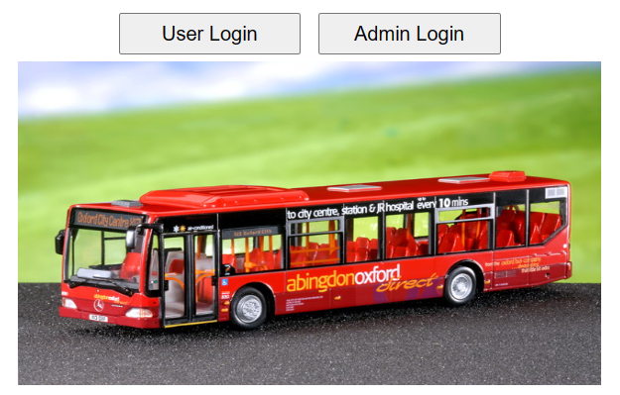

The TravelApp project outlines a comprehensive approach to ensure the application meets user and business expectations. This involved testing both functional and non-functional aspects of the application. Our project team consistently tested the application throughout the project lifecycle by following testing processes. The team performed the test plan implementation, functional testing of all TravelApp modules, and non-functional testing to verify aspects such as performance, security, and usability. The testing process followed by the team includes creating use cases, and RTM, preparing test cases and scripts, executing them, and documenting them in reports. The team has performed system testing, integration testing, and Load/Stress testing for this application to ensure efficient testing procedures. Various testing tools were used by the team to support the testing process, including test management tools such as Microsoft Project and JIRA, as well as automation tools like Selenium, JUnit, TestNG, Maven and JMeter. These tools facilitated test planning, execution, and reporting, ensuring efficient and effective testing practices.

By using the various automation and management tools, our project team has thoroughly and efficiently tested this application, ensuring that it meets the highest standards of quality and performance.

## **2.Number of Test Cases Planned by Business Areas:**

|  |  |
| --- | --- |
| **Business Areas** | **Number of Test Cases Planned** |
| User Login | 10 |
| User View Routes | 2 |
| Book Tickets | 15 |
| Cancel Tickets | 3 |
| Give Feedback | 8 |
| View Feedback | 2 |
| Admin Login | 9 |
| Admin Logout | 2 |
| Add Route | 8 |
| View Routes | 5 |
| Delete Route | 5 |
| Add Travel | 11 |
| View Travels | 7 |
| Delete Travel | 5 |
| Non Functional | 8 |
| Integration | 2 |
| **Total** | **102** |

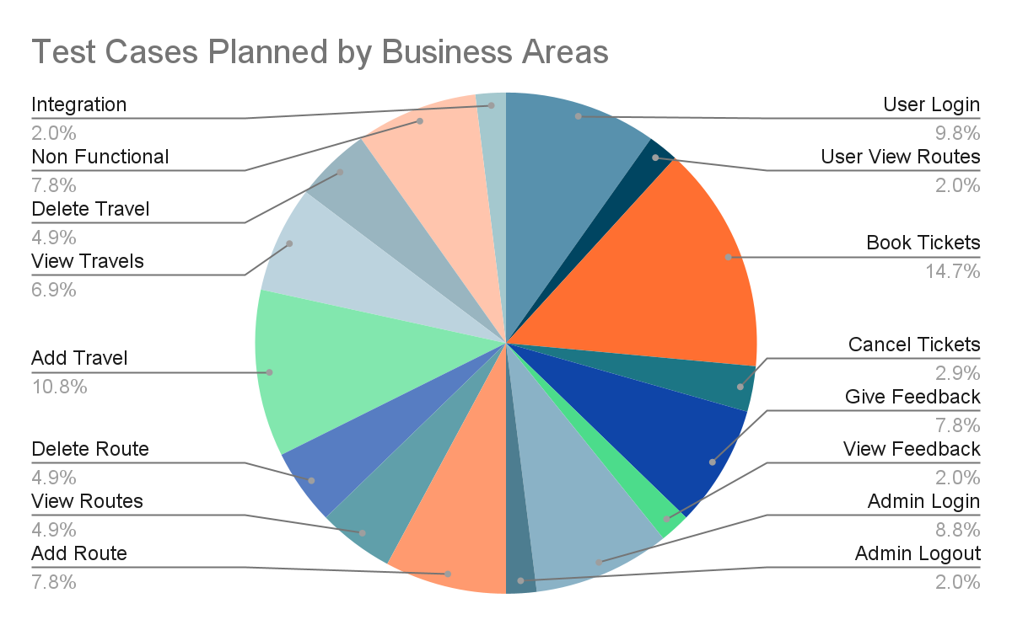

## **3.Test Execution Status by Business Areas:**

|  |  |  |  |  |
| --- | --- | --- | --- | --- |
| **Business Areas** | **Number of Test Cases Executed** | **Number of Test Cases Not run** | **Number of Passed Test Cases** | **Number of Failed Test Cases** |
| User Login | 10 | 0 | 9 | 1 |
|  |  |  |  |  |
| User View Routes | 2 | 0 | 2 | 0 |
| Book Tickets | 15 | 0 | 15 | 0 |
| Cancel Tickets | 3 | 0 | 3 | 0 |
| Give Feedback | 8 | 0 | 7 | 1 |
| View Feedback | 2 | 0 | 2 | 0 |
| Admin Login | 9 | 0 | 9 | 0 |
| Admin Logout | 2 | 0 | 2 | 0 |
| Add Route | 8 | 0 | 2 | 6 |
| View Routes | 5 | 0 | 4 | 1 |
| Delete Route | 5 | 0 | 5 | 0 |
| Add Travel | 11 | 0 | 2 | 9 |
| View Travels | 7 | 0 | 6 | 1 |
| Delete Travel | 5 | 0 | 4 | 1 |
| Non Functional | 8 | 0 | 8 | 0 |
| Integration | 2 | 0 | 2 | 0 |
| **Total** | **102** | **0** | **82** | **20** |

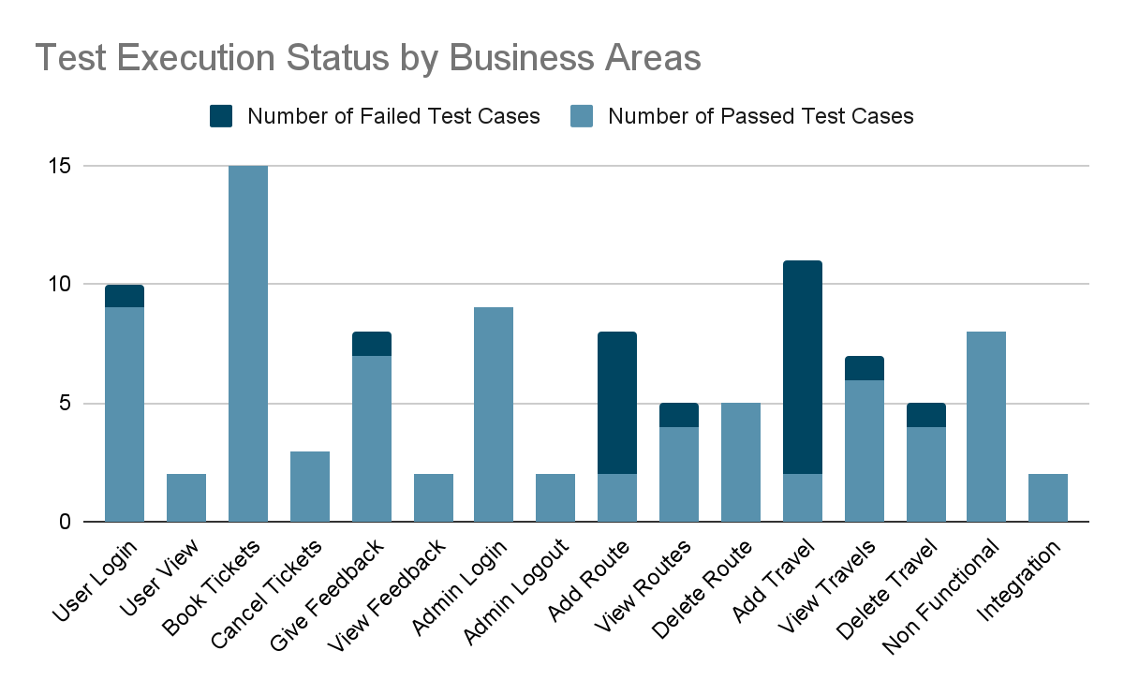

## **4.Testing types (Functional and Non -Functional)**

**Functional Testing:** Use automation tools like Selenium web driver to automate functional test cases.

**Integration Testing:** Verify that integrated components or modules work together as expected.

**Non-Functional Testing:**

· **Performance Testing:** Assess the system's performance metrics such as response time, and throughput using tools like Apache JMeter.

· **Usability Testing:** Gather feedback from different people to evaluate the application's usability, user interface design, and overall user experience.

· **Compatibility Testing:** Test the application across different browsers to ensure system compatibility.

## **5. Testing Schedule:**

**Date Range:** Jan 3rd - April 13th, 2024

|  |  |  |  |  |  |  |
| --- | --- | --- | --- | --- | --- | --- |
| **No.** | **Start Date** | **End Date** | **Duration** | **Location** | **Participants** | **Module Name** |
| 1 | **Jan 22, 2024** | **Feb 4, 2024** | 1 week | Virtual (Google Meet) | All team members | Test Strategy |
| 2 | **Feb 5, 2024** | **Feb 11, 2024** | 1 week | Virtual (Google Meet) | All team members | Test Plan |
| 3 | **Feb 12, 2024** | **Mar 5, 2024** | 3 weeks | Virtual (Google Meet) | All team members | Use Case Diagram, Use Cases, and RTM_PT |
| 4 | **Mar 6, 2024** | **Mar 12, 2024** | 1 week | Virtual (Google Meet) | All team members | Test Cases and Test Scripts |
| 5 | **Mar 15, 2024** | **Mar 23, 2024** | 2 weeks | Virtual (Google Meet) | All team members | Execution Cycle 1 |
| 6 | **Mar 26, 2024** | **Apr 4, 2024** | 2 weeks | Virtual (Google Meet) | All team members | Execution Cycle 2 |
| 7 | **Apr 4, 2024** | **Apr 8, 2024** | 1 week | Virtual (Google Meet) | All team members | Final Presentation |
| 8 | **Apr 8, 2024** | **Apr 13, 2024** | 1 week | Virtual (Google Meet) | All team members | Final execution report |

## 

## **6.Test management techniques utilized :**

The project team utilized various test management tools to plan and manage project activities throughout the software life cycle. These tools include Microsoft Project for project management, JIRA for bug-tracking and task organization, Google Meet for virtual team communication, Microsoft Excel for managing test cases, Microsoft PowerPoint for presenting project information, Microsoft Word for documentation and IAD logs to issue the logs. These tools helped in organizing and scheduling tasks, tracking test results, and generating reports to analyze testing progress.

The following screenshots illustrate how we used specific tools to manage the project.

1)**JIRA**

1a) JIRA Board (Current Sprint )

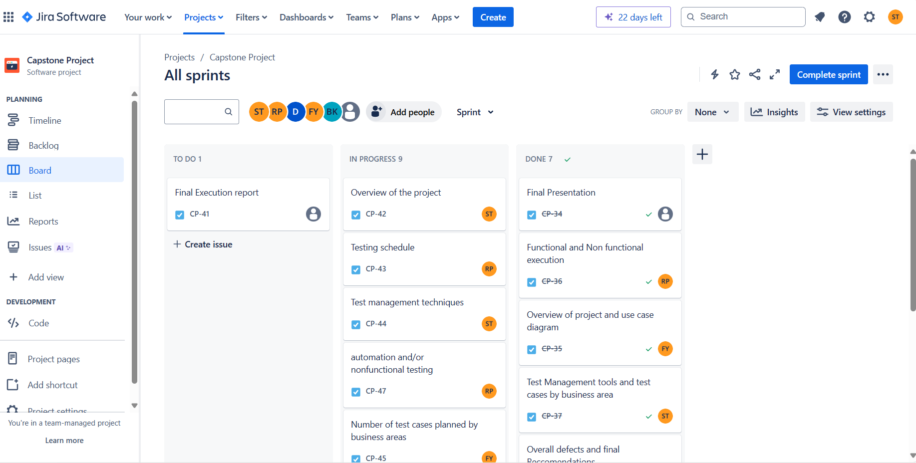

1b)JIRA -List of all tasks from sprint 1

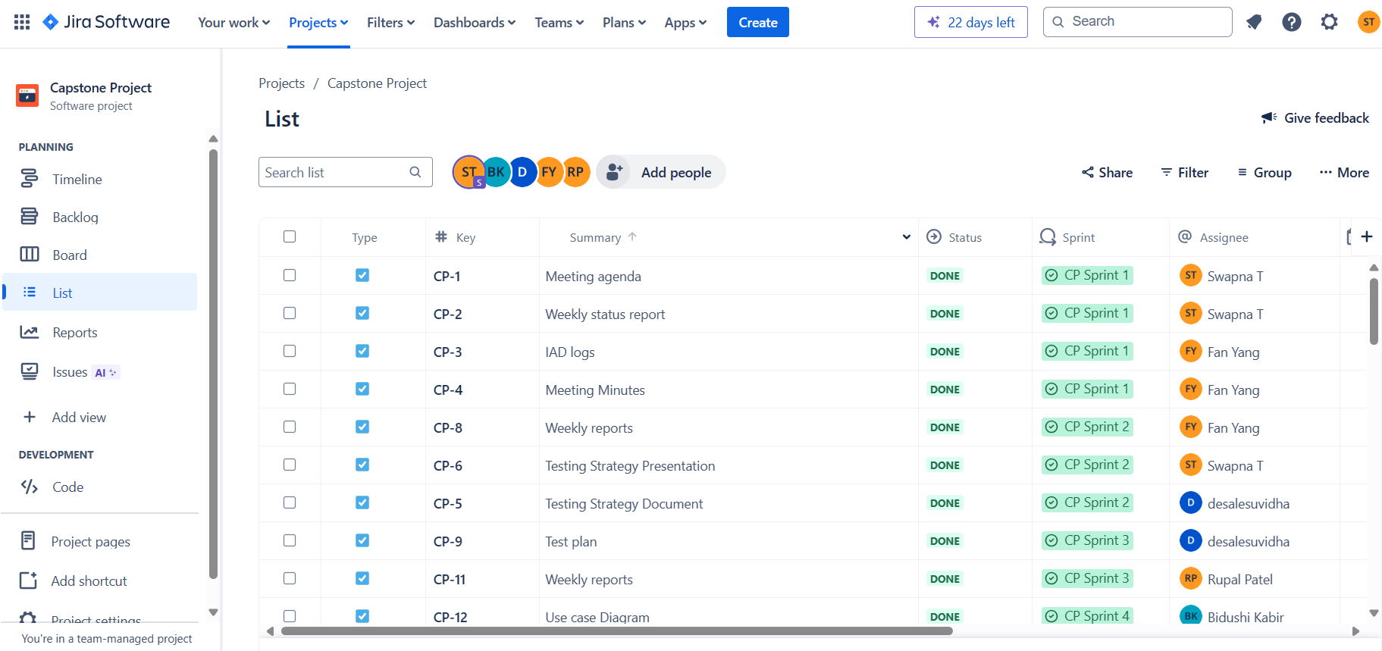

1c) JIRA Backlog for this sprint

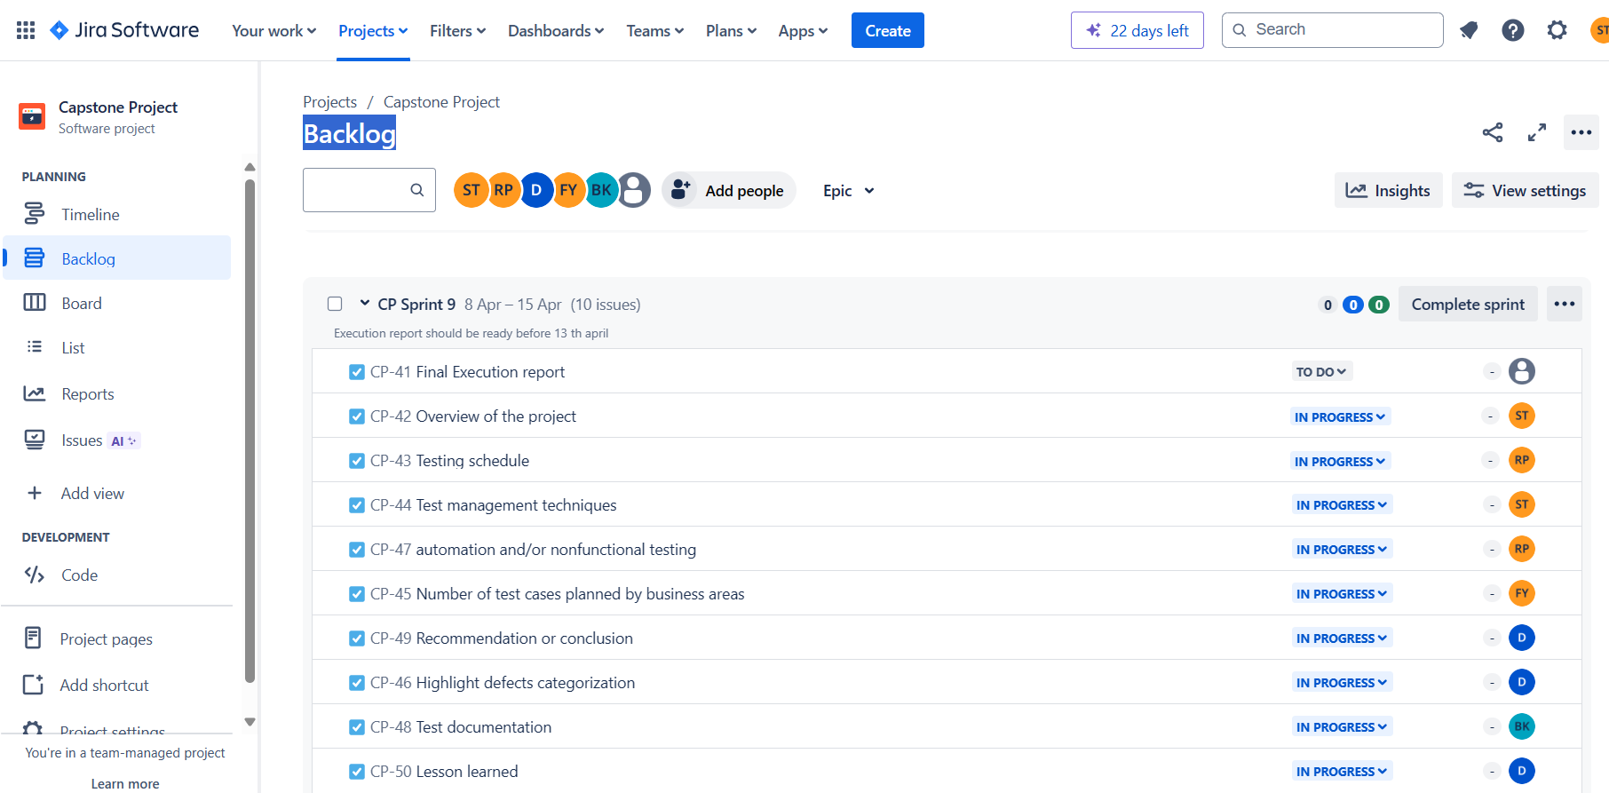

1d) JIRA Total Timeline

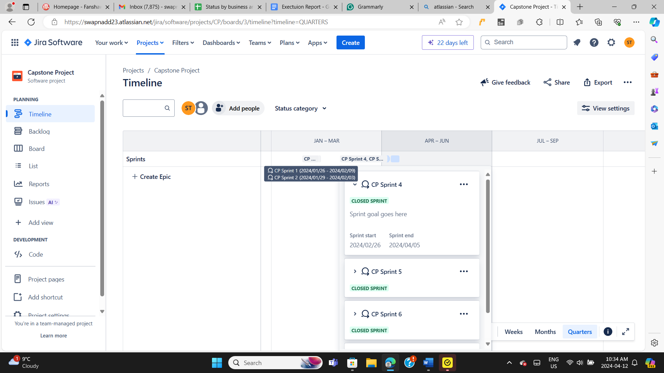

**2)IAD logs**

2a) IAD logs-Issues

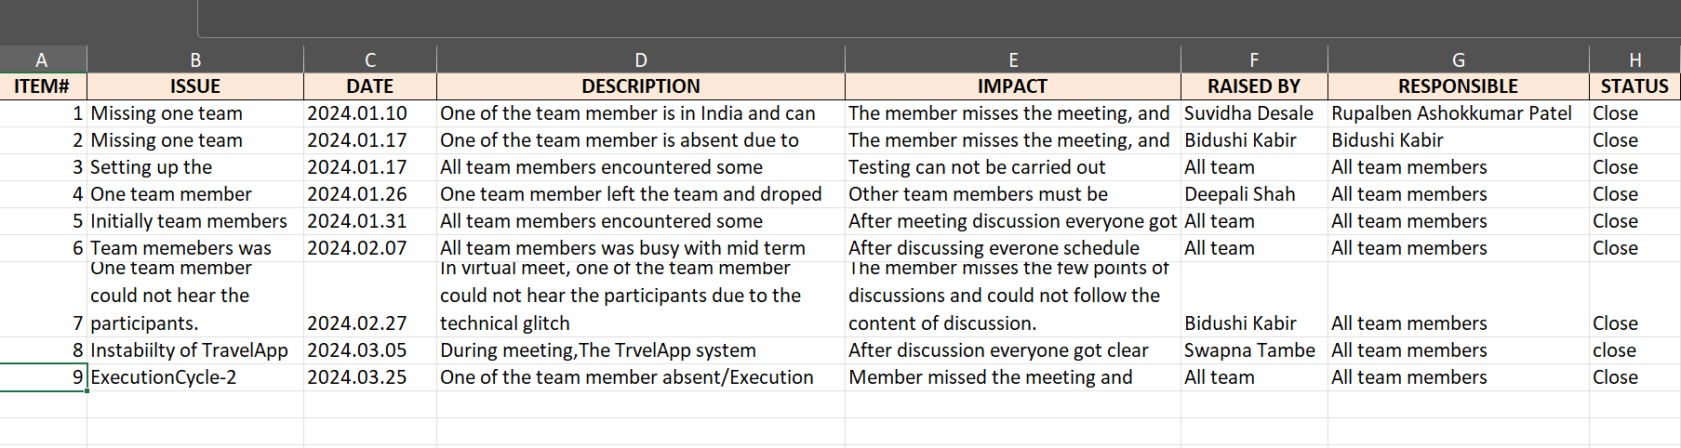

2b) IAD logs -Actions

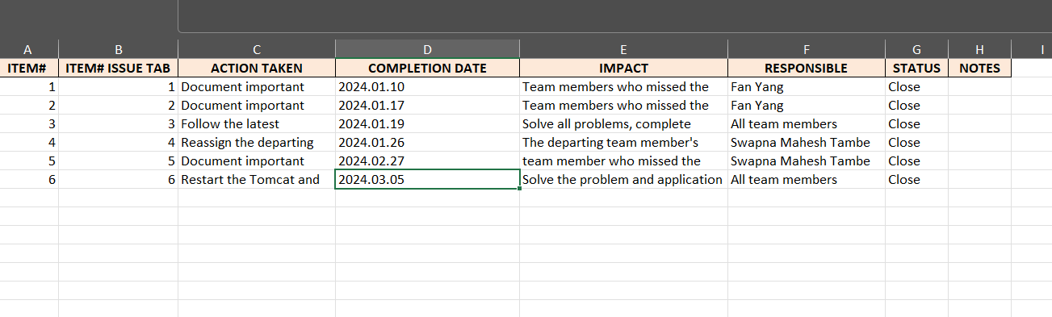

2c) IAD logs -Decision

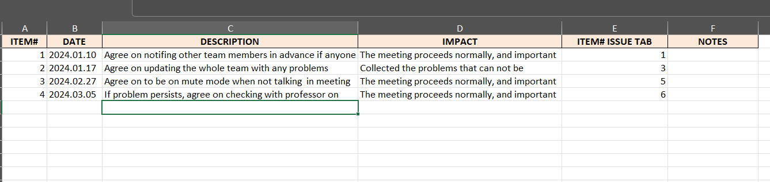

**3)MS Project**

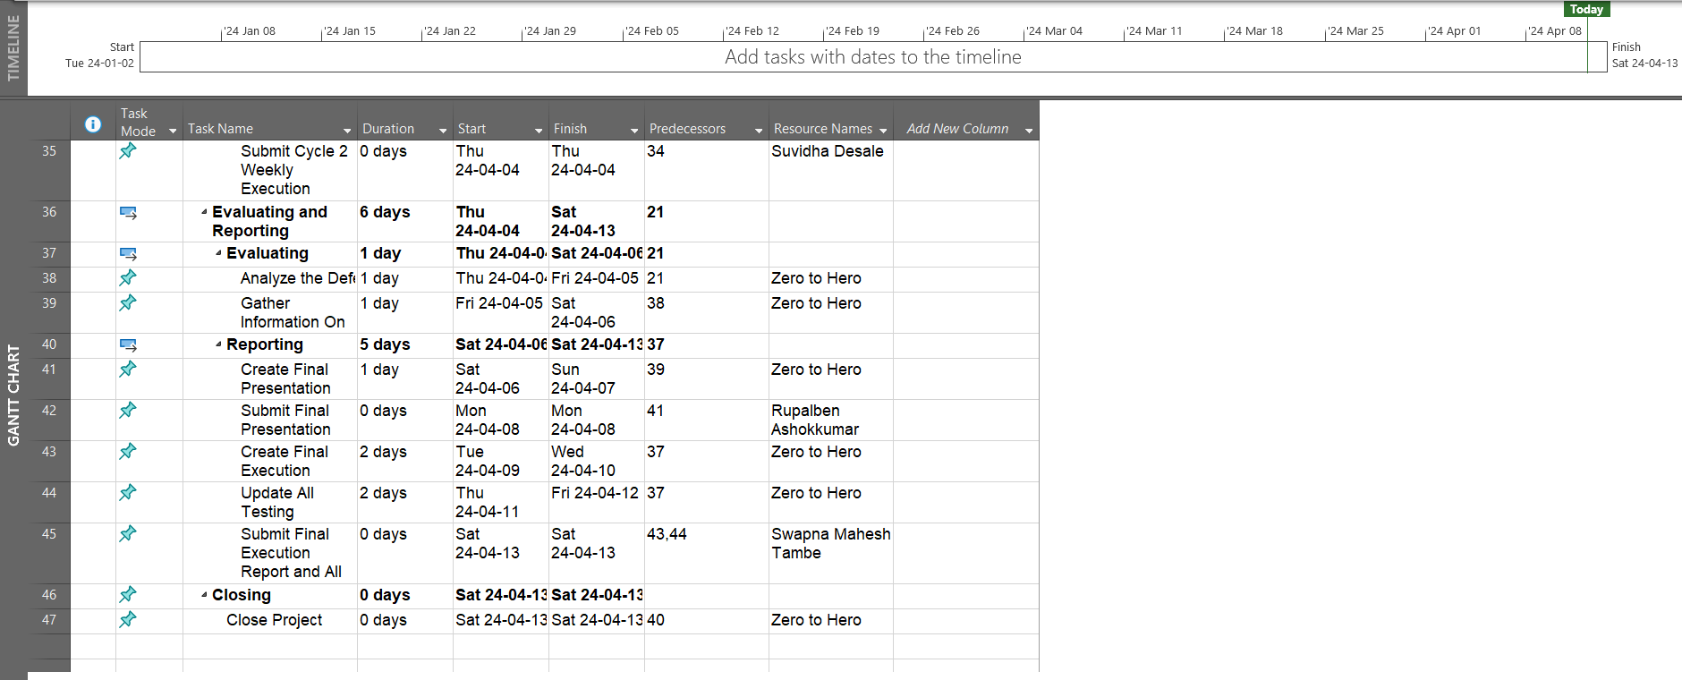

## **7. Highlight of defects :**

|  |  |  |  |  |
| --- | --- | --- | --- | --- |
| **Functional Area** | **Critical** | **High** | **Medium** | **Low** |
| User Login | 0 | 1 | 0 | 0 |
| Give Feedback | 0 | 0 | 1 | 0 |
| Add Travel | 0 | 8 | 1 | 0 |
| View Travel | 0 | 1 | 0 | 0 |
| Delete Travel | 0 | 0 | 0 | 1 |
| Add Route | 0 | 5 | 1 | 0 |
| View Route | 0 | 1 | 0 | 0 |
| **Total** | **0** | **16** | **3** | **1** |

## **8.Example documentation :**

**Walkthrough of a passing test.(View routes pickup point verification)**

1. Code to open the application in the browser

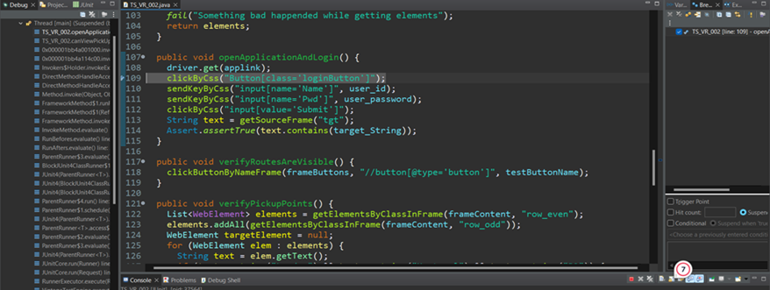

1. Travel App opened in web browser

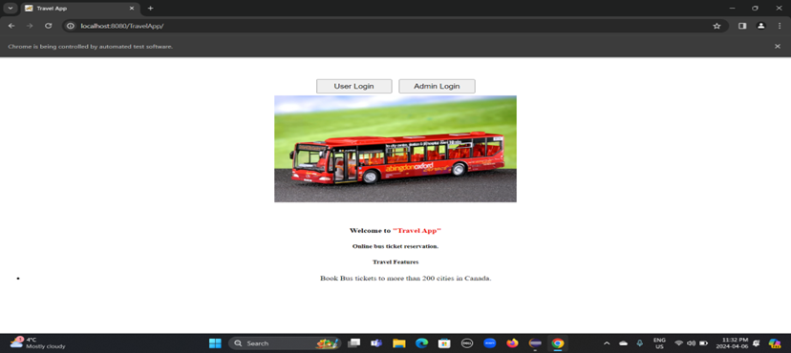

1. After clicking on user login button

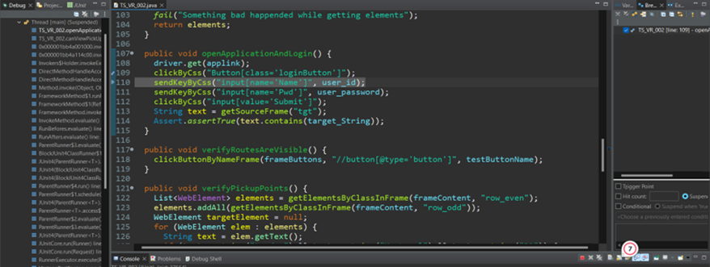

1. User login page opened in the browser

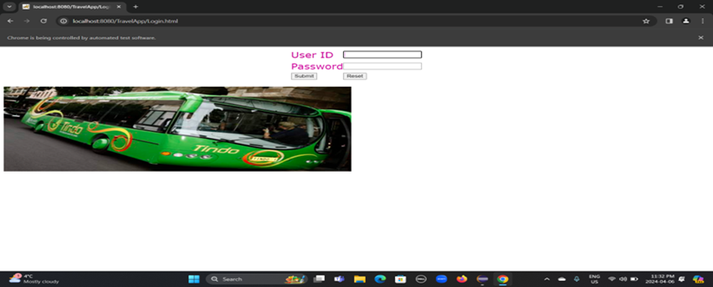

1. After filling the login information

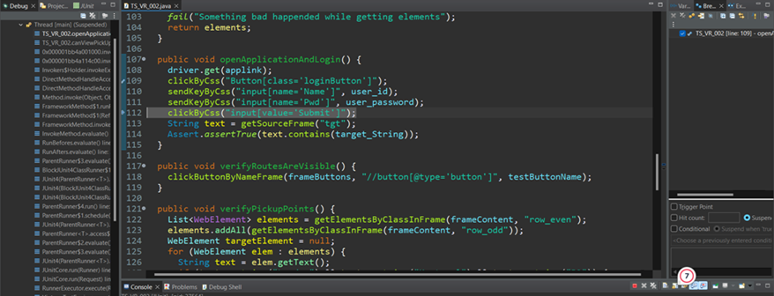

1. After filling the login information

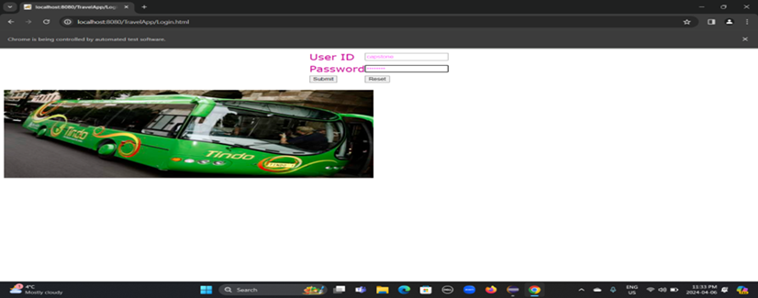

1. After clicking the submit button

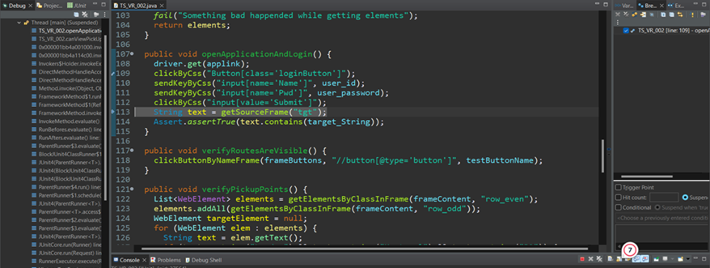

1. After clicking the submit button

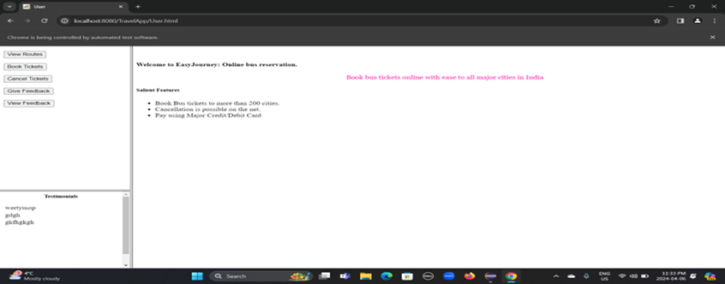

1. Verified user login successfully

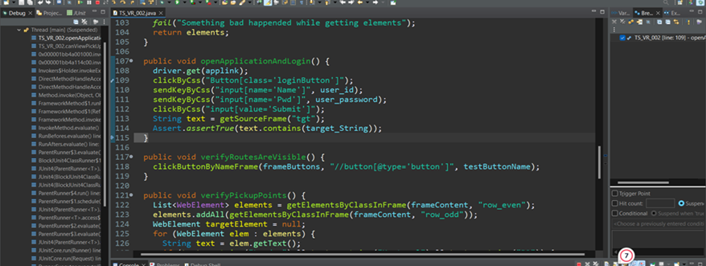

1. Next clicking on the ‘view routes 'button

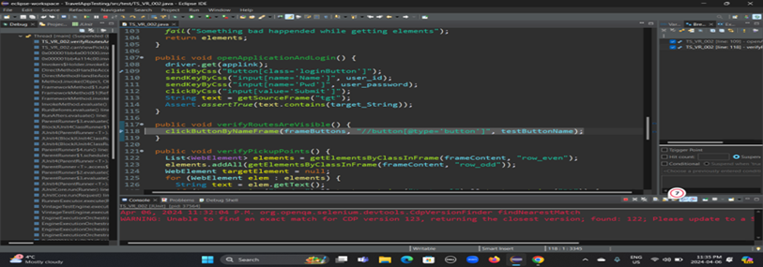

1. After clicking on the ‘view routes’ button

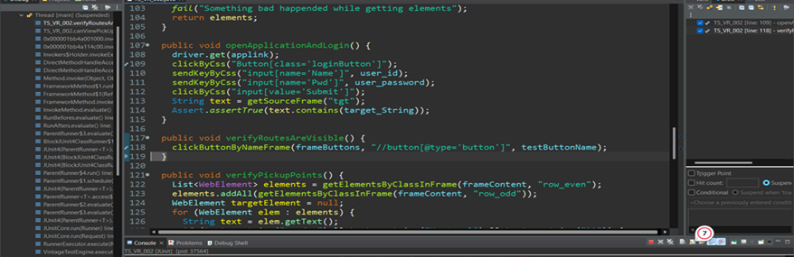

1. After clicking on the ‘view routes’ button

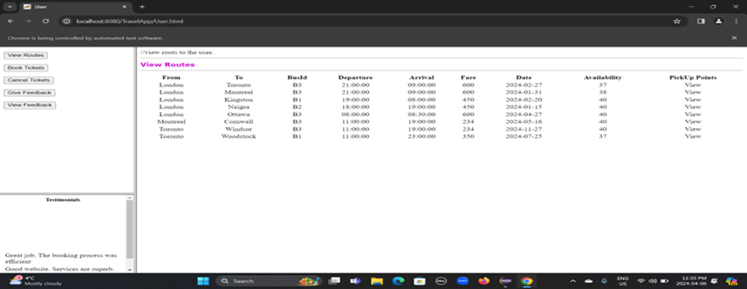

1. Before clicking the view pickup points button

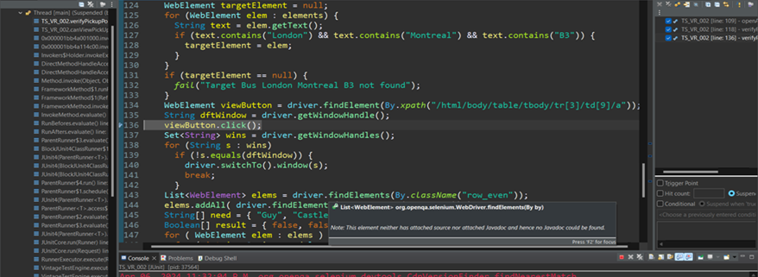

1. Before clicking the view pickup points button

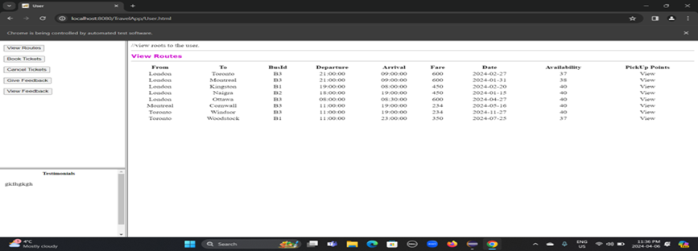

1. After clicking the view pickup points button

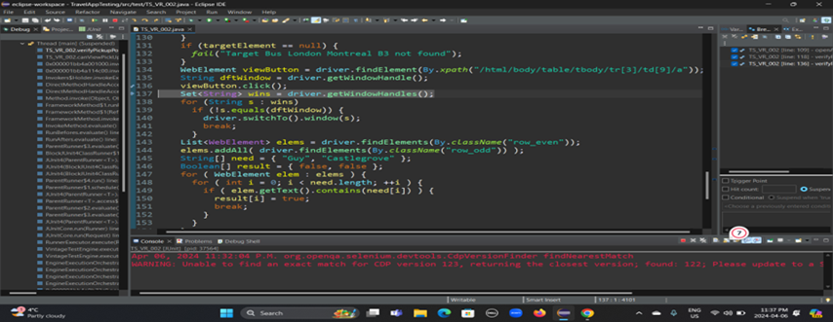

1. After clicking the ‘view pickup points ’ button

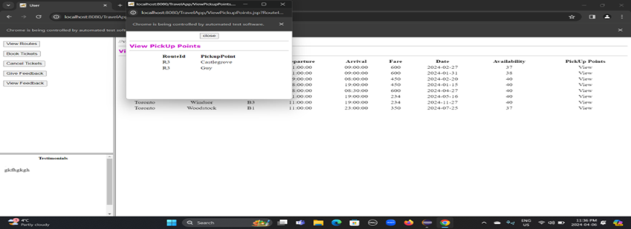

1. Switching to new window

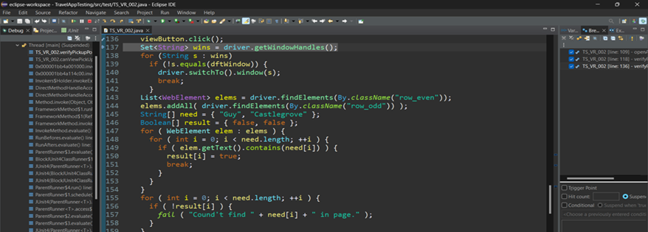

1. Collecting pickup points

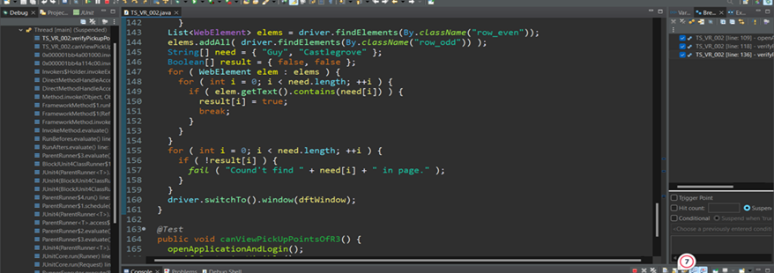

1. Verifying every pickup point are present

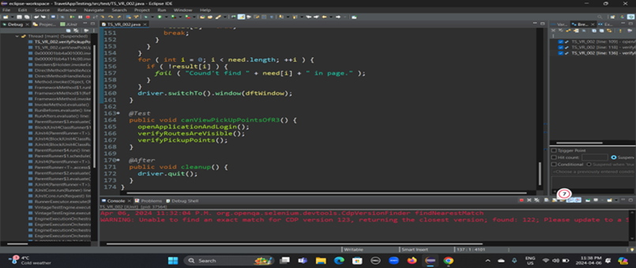

1. Finally, the execution result

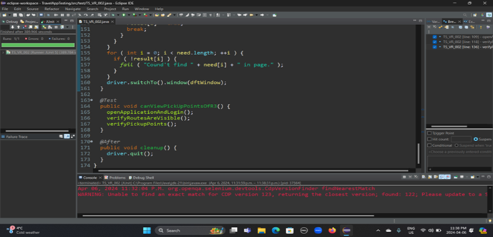

**Walkthrough of a failing test.(User login with empty user ID)**

1. After opening Travel App

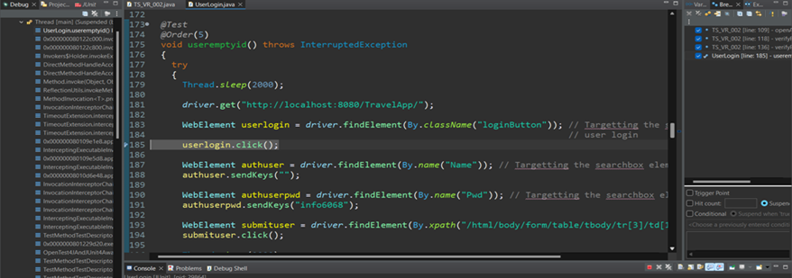

1. After opening Travel App

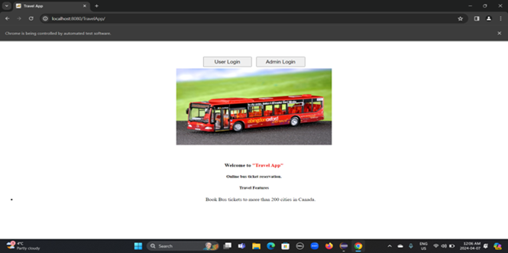

1. After clicking on user login button

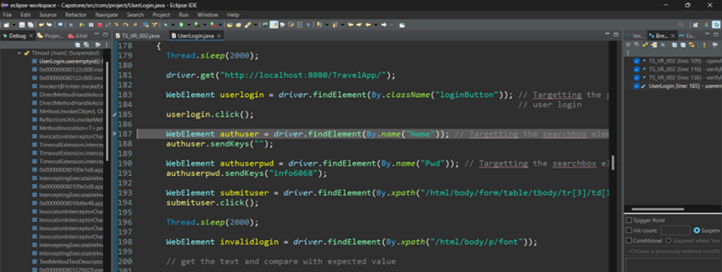

1. After clicking on user login button

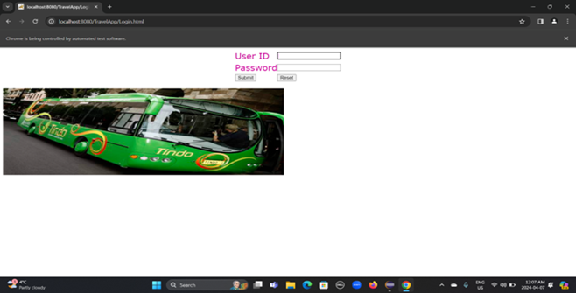

1. After filling the user login information

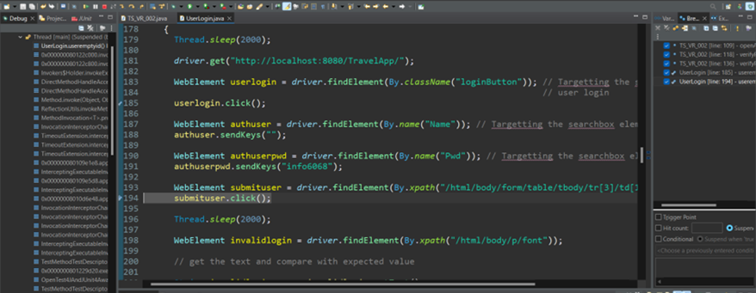

1. After filling the user login information

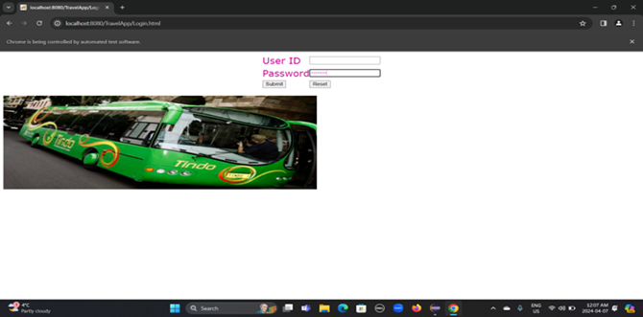

1. After clicking the submit button

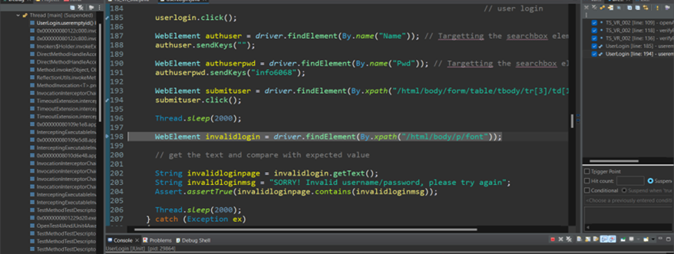

1. After clicking the submit button

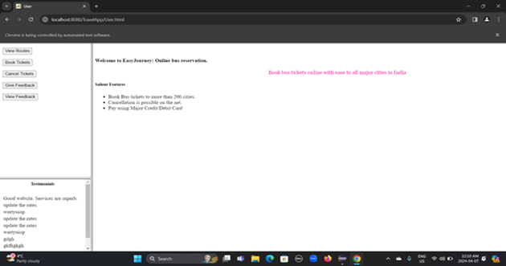

1. Something went wrong

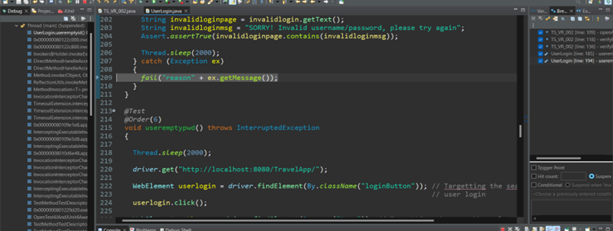

1. Finally, the execution result

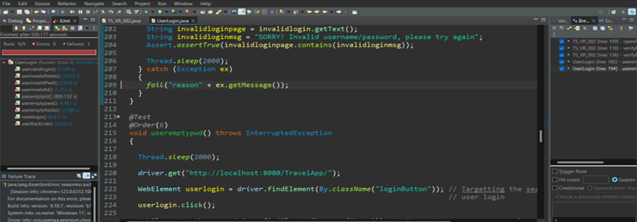

**An example of a defect report.(Back button broken on invalid login)**

**Recreating a defect from a defect report.(Back button broken on invalid login)**

1. **Defect reproduce step 1**: We navigate to the TravelApp web application to open it in our browser.

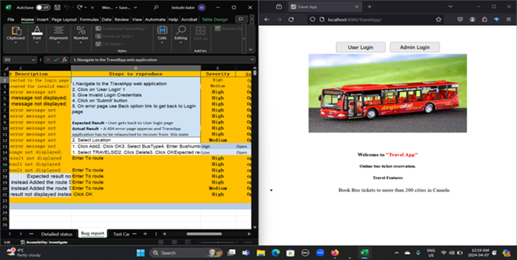

1. **Defect reproduce step 2&3** :Then I need to put User ‘Login details’ and invalid Login Credentials details.

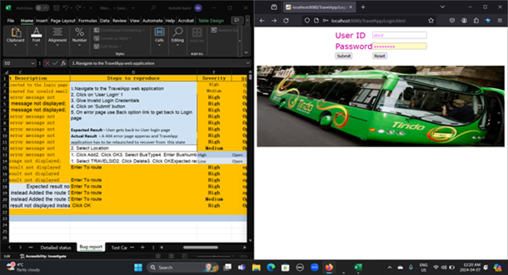

1. **Defect reproduce step 4**: Click on the Submit Button. Then one error page appears with details ‘Sorry! Invalid username /password, please try again’.

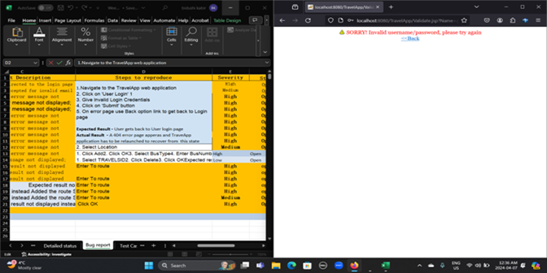

1. **Defect reproduce step 5** : From the error page when we tried to get back to the Login page we clicked the Back button option. As I user I expected that it would go to the Login page. But it did not.one more page appear with HTTP Status 404-Not found(code error-software broken).

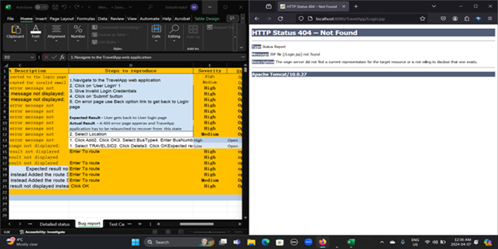

## **9.Final recommendations & Lessons Learned:**

Since January, Travel Application testing is completed for different modules like administrative, travel etc. Travel application testing is completed manually as well as automation scripts are developed and tested.

We covered almost 100% testing of travel applications except non-functional. We do find some functional defects in different modules as follows…

|  |  |  |
| --- | --- | --- |
| **Module Name** | **No. of Defects** | **Test Coverage** |
| Use Login | 1 | 90% |
| Feedback Module | 1 | 88% |
| Add Route | 6 | 50% |
| View Route | 1 | 90% |
| Add Travel | 9 | 18% |
| Delete Travel | 1 | 85% |
| View Travel | 1 | 80% |

After completing the automation testing, we did find any critical issues in the other functional areas only found in the Add Travel, also found High severity and medium severity defects too. From the above test coverage, Statistics showed that we will improve the quality of the testing for some of the functional areas such as Add Travel for the future project and also to maintain the test coverage we will choose the quality automation framework.

**Limitations**: All the team worked in a different envirnoment some of them used Firefox, Microsoft, Chrome driver so it impacts on the overall test results which may different from those in the expected Environment. Due to insufficient testing resources results in the limited test coverage.

**Lesson Learned**: Throughout the project all the teammates worked effectively We all had weekly meetings to discuss the project and focused on issues. After understanding the above limitations enables us to implement the strategies to improve the overall quality of the product. We will use the sophisticated test tool to make our teamwork more efficient . For the future project, we will have clear goals so we will not make mistakes and deliver the project on time.